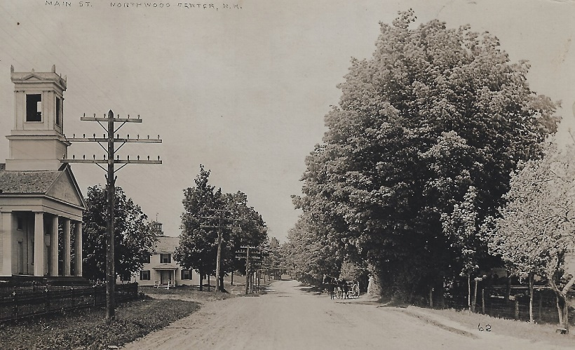

Town of Northwood, NH
250th Steering Committee

Addenda for March 4, 2021 meeting
Northwood Community Hall, 6:30 PM
Open to the public, new members welcome. Per Board of Selectmen Covid-19 Regulations: social distancing, masks must be worn at all times and occupancy is limited to 10 in attendance.
Roll call
Acceptance of minutes of the February 3, 2021 meeting
Old Business
Updates from committee members on fact findings: cookbook, yardsticks
Survey form responses
Review of souvenir suggestions
Make a list of subcommittees that will be needed
Start work on setting a budget
Suggestions for date or dates for event
Locations for events

New Business
Adjournment

