Project Proponent: Town of Northwood, NH
The Sherburne Brook Bridge Project consists of the bridge replacement and upgrade of the Sherburne Brook Bridge; reclaiming and top-coating of East and West Bow Lake Road, which approaches the bridge; and upgrading the shoulders and drainage on the road to prevent erosion near the bridge and on Mary Waldron Beach, which abuts Bow Lake Road.
Located between Dover and Portsmouth, Northwood, New Hampshire is the center of the Route 4 Commerce Corridor (RFCC). Northwood’s access to the state highway system provides access to lakes for tourism, space for restaurants and antique shops and easy access to educational opportunity at Coe-Brown Academy; the Town’s highway infrastructure is its chief economic asset. The Town relies on two arterial roads to connect itself and the surrounding towns to the RFCC. Of the two roads one of them, Bow Lake Road, has a 78-year-old bridge that reached the end of its useful life 28 years ago and has been placed on the New Hampshire Red Listed Bridge list. The Bridge and adjacent road is extremely deteriorated necessitating weight restrictions and closures that adversely impact commerce, economic development, traffic congestion, tourism, and transportation efficiency in the Town and surrounding areas to a significant degree. If the bridge is closed permanently, school busses, fire trucks, ambulances and commercial vehicles will need to use a longer and cumbersome alternate route. The Town is requesting funding to help with the replacement of the bridge over Sherburne Brook and the reconstruction of 2.1 miles of road from the Town Line to the RFCC.

Project Benefits
- Coe-Brown academy is ranked the third best high school in the state of New Hampshire and relies on Bow Lake Rd. for bus routes. Access to education will improve after eliminating the restrictions on the bridge and eliminating bridge closures which force lengthy detours for busses transporting school children and parents dropping children off at school.

- The same detours around the bridge stifle economic opportunity by delaying deliveries of fuel to homes and other commercial trucking that rely on Bow Lake Rd. This grant will enhance public safety because fire apparatus, ambulances, and police will not need to take the long alternate route around the bridge, improving response times for emergency services to the remote areas of the Town.

- The environment and threatened species will be protected if the bridge is replaced. Any detour around the bridge places heavy traffic at the door step of threatened species like the American Loon and near pristine water bodies.

- Public health will be positively affected when detour routes that are on rural roads running past many lakes and streams end, thus reducing emissions along the 15-mile detour and preventing run off of petroleum products that come from cars and trucks running into water bodies.

- Bow Lake Rd. is part of Northwood’s principle North-South arterial road system and has an entrance to Coe-Brown Academy. Replacing the bridge and rehabilitating the road will prevent catastrophic traffic congestion on Route 4, and the economic, safety, health, and environmental impacts of a full bridge and road closure.

- Environmental sustainability will be improved by replacing the bridge. There is an old mill pond just south of the bridge that floods in heavy storms and has flooded the road in the past. Replacing the bridge will prevent road flooding, and road debris, road salt, and portions of the road will not be washed into the nearby lake.
Project Schedule | Start | Complete
Grant Agreement Negotiation (anticipated) | Jul-16 | Oct-16
Permitting & Approvals | Nov-16 | May-17
Design | Jun-17 | Oct-17
Construction Procurement | Nov-17 | Apr-18
Construction | Apr-18 | Nov-18
Funding Sources | Amount
TIGER VII Request | $1,021,706
Town of Northwood | $100,000
Coe-Brown academy | $1,000
TOTAL | $1,122,706

Funding Use Breakdown
Design | $93,790
Construction | $925,060
OPM, Field Representation, etc. | $11,350
contingency | $92,506
TOTAL | $1,122,706
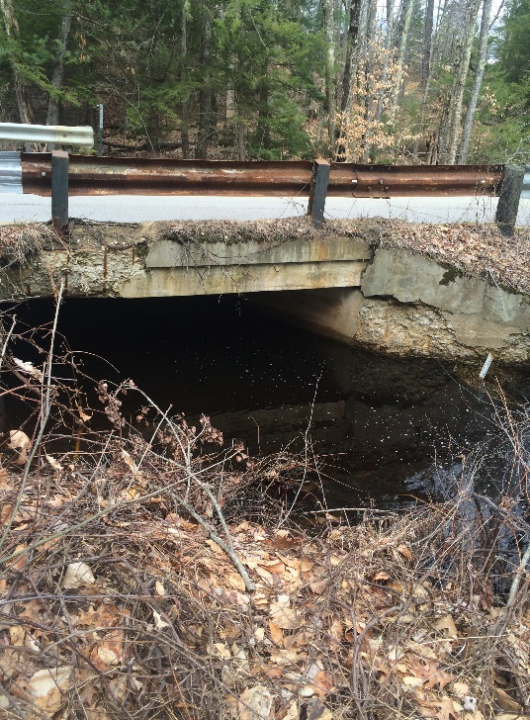

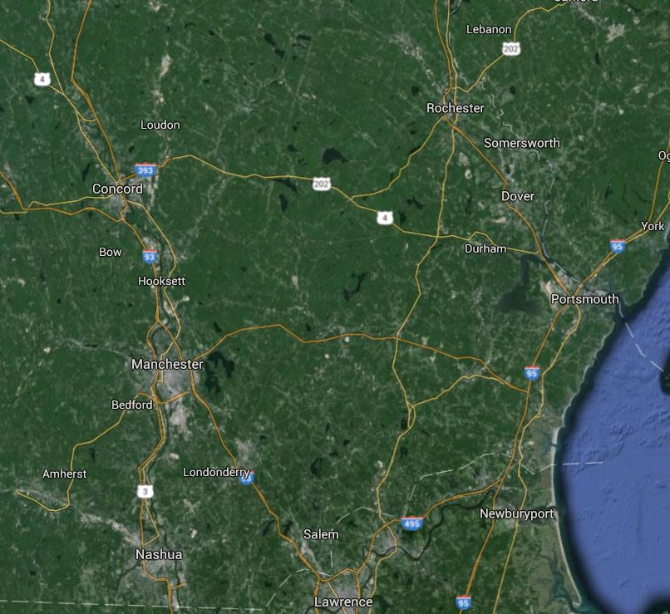
Location

