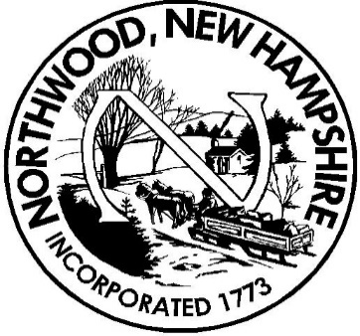

TOWN OF NORTHWOOD, NH

PUBLIC NOTICE

NOTICE OF CONTINUED TOWN MEETING

PURSUANT TO EMERGENCY ORDER #83, THE NORTHWOOD BOARD OF SELECTMEN, IN CONSULTATION WITH THE MODERATOR, HAS DETERMINED THAT THE NORTHWOOD ELEMENTARY SCHOOL WILL BE UNSAFE TO CONDUCT THE NORTHWOOD TOWN MEETING ON JANUARY 30, 2021 AND MARCH 9, 2021 DUE TO THE ONGOING PANDEMIC.

THE DELIBERATIVE SESSION OF THE NORTHWOOD TOWN MEETING IS THEREFORE CONTINUED UNTIL SATURDAY, MAY 15, 2021 AT 9:00AM. THE MEETING WILL BE HELD AT Northwood Elementary School.

BALLOT VOTING WILL OCCUR ON JUNE 8, 2021 FROM 7:00am TO 7pm AT Northwood Elementary School. ALL APPROPRIATE COVID 19 PRECAUTIONS WILL BE TAKEN TO ENSURE THE SAFETY OF VOTERS AND POLL WORKERS.

