Town of Northwood, New Hampshire
818 First New Hampshire Turnpike, Northwood NH 03261 Building Department
(603) 942-5586 ext. 2003 Fax (603) 942-9107

Permit # _

BUILDING PERMIT APPLICATION

Project Address
Private Road or Class VI Road Frontage? _____ Yes ____ No
If Yes, a separate Private Road/Class VI application must also be completed and submitted with this application.

Map # _ Lot # Flood Zone _____ Yes ____ No Steep Slopes _____ Yes ____ No

Property Owner Phone #

Mailing Address

Email Address ______________________________________________________________
Contractor Phone #

Mailing Address

Project Type: New Construction __ Addition __ Alteration __ Renovation__ Demolition__
Sign __Accessory Structure __ADU __Change of Use __Other __

Existing Use

Proposed Use
Current status? Year Round______ Seasonal _____
Does this application include conversion from Seasonal to Year Round Use? Yes___ No ____

Distance from nearest property line (new construction) : __________________________________
Distance from any proposed structure to wetland, including poorly drained soils? ______________

Number of Stories
Total Height of Construction
Total Square Footage __________

Description of Work _______________________________________________________________
_______________________________________________________________________________
_______________________________________________________________________________
_______________________________________________________________________________
Estimated Cost of Construction $. . Over --→

Application continued.

Additional Information

I hereby certify that as the applicant for this permit, I am the owner of the subject property or the owner’s authorized agent. I hereby declare that the statements and information contained in this application and submitted in conjunction with this application are true and accurate to the best of my knowledge. I understand that I am responsible to ensure all construction or other work will be completed in accordance with all Federal, State, and Local laws codes and ordinances including but not limited to the State of New Hampshire Building Code NH RSA 155-a.
I understand I am responsible to ensure all inspections will be completed as required by the Town, and no structure or improvement will be occupied or utilized without a Certificate of Occupancy, or Certificate of Completion having first been issued. Any deviation from the plans and specifications submitted will require the approval of the Building Official.
A permit may become invalid if work is not started within 180 from the date of issue or if the work is abandoned or suspended for a period of 180 days.
By signing this permit application, the owner or the owner’s agent, authorizes access to the property by Town Officials to conduct interior and exterior inspections and property assessments during and/ or after the construction process.

Applicant name, (print) Applicant Signature

Address

Date Applicant phone #

This area for building official use only:

Lot Coverage %:

Date paid:

Permit Fee:

Check # / Cash:

Permit # Date Permit Issued:

Building Inspector’s Signature

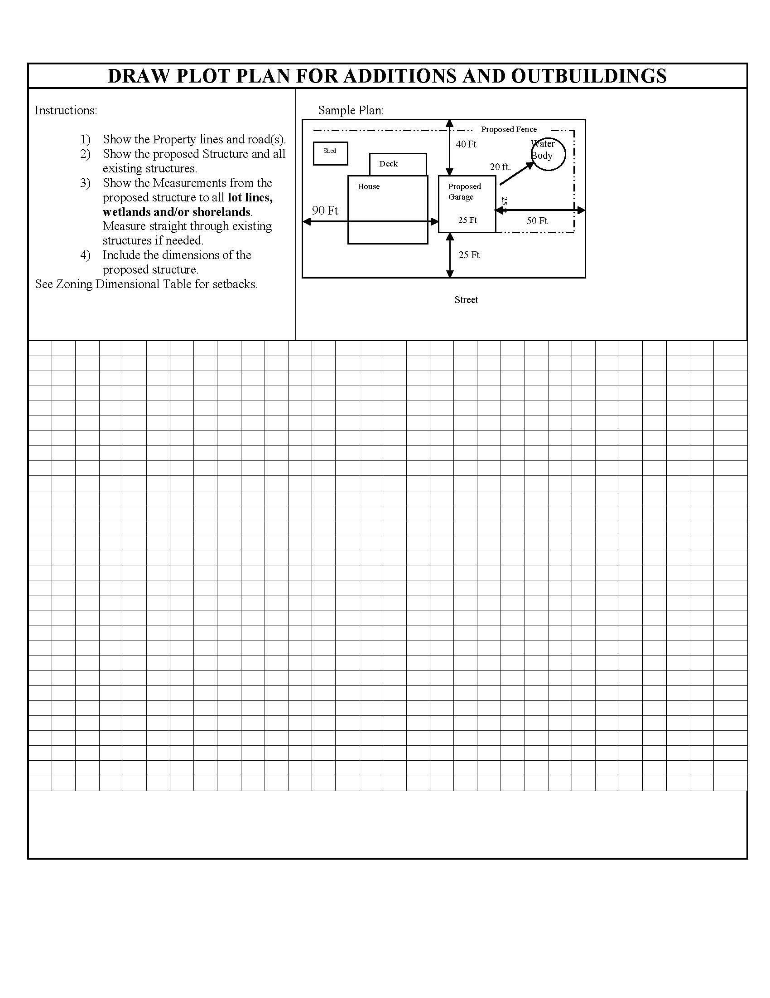

APPLICATION FOR DRIVEWAY PERMIT

Permission is requested to build/rebuild a driveway entrance to my property on the _____ side of Road/Street in the Town of Northwood, N.H.
Map/Lot Number. The driveway is for access to ◻ residence ◻ business
As the landowner applicant, I hereby agree to the following:
- to construct driveway entrances only for the bona fide purpose of securing access to private property and in such a way that the highway right-of-way is used for no other purpose than travel.
- to furnish and install drainage structures that are necessary to maintain existing highway drainage and adequately handle increased runoff resulting from development. Minimum culvert size to be 12”.
- that the location and construction of the driveway is in conformance with zoning board and/or planning board approval.
The completed driveway is subject to approval by the Northwood Road Agent.
PROVIDE LOCATION SKETCH BELOW
Signature of Property Owner

_
Print Name of Property Owner

Physical Address

Mailing Address

Telephone Number

Construction approval Approval for use – Construction completed Per approval of (date at left).
By: Easement Signed Date

Date: _ By:

Requirements: _ Date:

(Easement signature required only when easement is necessary.)

SUBJECT TO ALL APPLICABLE FEDERAL, STATE & LOCAL REGULATIONS AND ORDINANCES. THIS PERMIT DOES NOT GRANT PERMISSION TO COMMENCE CONSTRUCTION WITHOUT PERMIT ISSUANCE OR FINAL PLAN APPROVAL.

Road Agent Signature
Approved
Date

