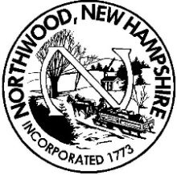
MEMORANDUM - OFFICE OF THE TOWN ADMINISTRATOR

TO: Board of Selectmen
FROM: Walter P. Johnson, Town Administrator
RE: Weekly Report
DATE: December 21, 2020

Town Administrator: This past week's activities included: Participated in conference calls with NHHSEM regarding the Covid-19 pandemic; prepared for and attended the Select Board meeting, worked on year end expenditures and encumbrances; and prepared notices for DPW Laborer II vacancy. Also, finalized the lease/purchase financing for the new ambulance; met with Mainstay Computer Services to review their services; and reviewed and processed Human Services request.
This week's activities include: review and process Human Services requests; prepare draft agenda for 12/29 Select Board meeting; prepare encumbrances for 12/29 board meeting; investigate status of records preservation plan and contact vendor for quote; and review repurchased property from 2020 Also, participate in conference calls with NHHSEM regarding the Covid-19 pandemic; begin preparations for new finance director; and prepare reports for annual town report. Have a great week. Be well and stay safe and have a very happy holiday!
Assessor: Our contract assessor continues to hold telephone hearings with property owners to discuss their values.

Finance: No report this week.
Tax Collector: No report this week.
Department of Public Works: Highway department reports that we have been plowing multiple storms with 2 call out for black ice at night. Preparing for heavy rain to come in on Thursday and Friday up to 3- 4 inches to be expected; 6 loads of sand delivered with 2 loads of salt; all sand salt bins full in preparation for the next snow storm. Highway crews will be out all week pushing banks back for visibility for cars pulling out onto rt 4 and shelfing snow banks on every road we plow. Respectfully submitted, Chris Brown

Fire Rescue: Below is an outline of happenings at the Fire Department

- I am happy to report currently we have no members in quarantine or active COVID-19 cases among our member
- We have submitted our roster to the State for COVID-19 vaccinations
- We continue to respond to a high percentage of COVID-19 positive calls, all members are wearing appropriate PPE.
- We have completed hose and ladder testing. We only had a small number of sections of hose fail the test, however we have over 1000' feet of hose that are too old to be in service
- Under the direction of Sandy Priolo all Santa's Helpers gifts have been wrapped and delivered.
- We finally took delivery of our new thermal imager, we will be training with this new equipment and putting it in service on Engine 1
- The Frye family made a very generous donation of an over the range microwave oven to the department. The appliance has been installed. Thanks to the Frye Family.

Police Department: No report this week

Weekly Report from Linda Smith, Land Use Specialist

Planning Board
Scheduled December meeting, including public hearing on zoning amendments, did not occur due to lack of quorum. Chairman Strobel re-scheduled the public hearing for January 7 and pending cases to January 14. The cases will require new notification to the public and abutters at the town’s expense.

Zoning Board
One case pending that is a re-hearing of a case heard in October- applicant seeks to develop a 0.5-acre lot on corner of Big Buck and Bigelow Road. Scheduled for Dec. 28. Attorney Spector-Morgan will be attending for the board.

Conservation Commission
Nothing new to report.

Budget Committee
Not scheduled until January

Police Commission
Nothing new to report

Town Report
Deadline is Monday, January 4. Confidential email sent regarding dedication

Library: No report this week

Northwood EMD’s report for week prior to 12/21/20

- Emergency Management’s continued concern is the rise in COVID-19 cases within the town and in surrounding towns. This past week the number of active cases in town remained above 30, and was averaging 2 to 3 new cases daily.

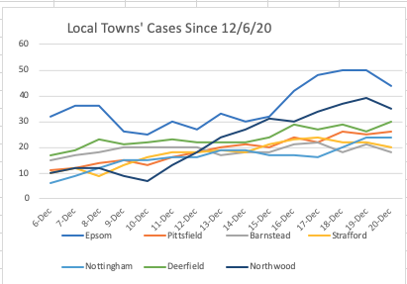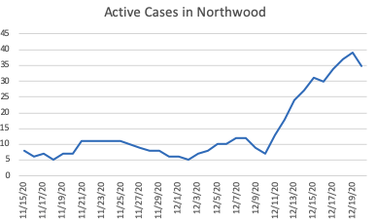
- FDA granted EUA for the Moderna vaccine. There are now two vaccines approved for use, with the Pfizer vaccine having been approved last week. NH has commenced Phase 1a vaccinations.

- EMD continues to provide daily briefings each evening including a SIT REP each Friday and Emergency Orders, Health Alert Network documents and State Issued Guidance as they become available. Weather updates are provided as needed.

- Upcoming concerns include the School and Town Deliberative Sessions in February and the town election in March. Most residents will not be receiving the vaccine until April at best.

- Northwood experienced its second winter event this past week with plus or minus two feet of snow falling on the town. No major outages were reported. Drought conditions have improved from extreme to severe and are predicted to be back to normal by March.

- I have received notification from DES of a number of local food establishments dropping their public water supply designation. This could mean the businesses have closed their doors, moved to take-out or are now serving less than 25 customers. Back in March, former Selectman Hadley and Selectmen Frye had created a subcommittee to address local business economic concerns. Is that subcommittee still in place? The town should consider tracking businesses in need as we enter the COVID-19 recovery period in late Spring.

