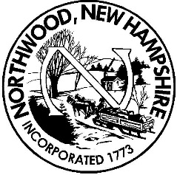 Board of Selectmen
Meeting Agenda
Northwood Town Hall
December 21st, 2018
5:00 p.m.

- Call to Order, Roll Call and Pledge of Allegiance

- Public Hearing – None scheduled

- Non-Public Session RSA 91-A:3, II (a – personnel, b – hiring of public employee)

Appointments 5:30 and 6:15

- 2019 Warrant motions pending

- New Business
  - Acceptance of Minutes
  - Process Various Assessing Forms and Applications
  - Approval of Manifest(s)
  - Approval of Purchase Orders
  - Miscellaneous Signatures/Approvals

Reports
  - TA’s work requiring directives from BOS
  - Individual Selectman’s Reports

- Citizen’s Forum (no more than 3 minutes per person at Board's discretion)

- Adjournment

Any person requiring interpretive or other accommodations is asked to contact the Town Office at least 48 hours prior to the start of the meeting.

