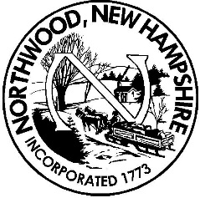 **Board of Selectmen**

**Meeting Agenda**

**Northwood Town Hall**

**November 19, 2018**

**5:00 p.m**.

1. **Call to Order, Roll Call and Pledge of Allegiance**
2. **Non-Public Session RSA 91-A:3, II (a, b, c & e) –personnel, hiring of public employee & reputation of any person, other than a member of the board, & legal**

**5:15 PM Wage Study nonpublic items**

**5:30 PM Non-Public appt. RA**

**5:45 PM Non-Public appt. TC/TX**

1. **6:00 Operating Budget and Default Budget – Finance Administrator Attending**
2. **Non-Public Session RSA 91-A:3, II (a, b, c & e) –personnel, hiring of public employee & reputation of any person, other than a member of the board, & legal**

**6:30 PM Non-Public appt.**

1. **Job Description and Wage Study**
2. **W arrant Completion Work session**
3. **Interim Town Administrator Items**
4. **Board of Selectmen report**
5. **Adjournment**

Any person requiring interpretive or other accommodations is asked to contact the Town Office at least 48 hours prior to the start of the meeting.