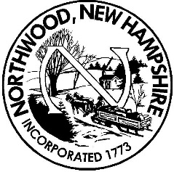 Board of Selectmen
Meeting Agenda
Northwood Town Hall
November 13, 2018
6:00 p.m.

- Call to Order, Roll Call and Pledge of Allegiance

- Non-Public Session RSA 91-A:3, II (a, b & c) – hiring of public employee & reputation of any person, other than a member of the board

6:00 PM Non-Public appt.

- Public Hearing – None scheduled

- Citizen’s Forum (no more than 3 minutes per person at Board’s discretion)

- Appointments – 6:30 PM Fire Chief Bassett/Representative– apparatus quote

6:45 Fire Chief Bassett/Representative & Finance Administrator Garrett – call wage and process
7:00 Highway Dept.-Pete Elliott – department update and budget.
7:15 Conservation Comm. – Wini Young

- FY 2019 Warrant Review session

- Unfinished Business

List of unfinished projects in TA office

- New Business
  - Acceptance of Minutes
  - Process Various Assessing Forms and Applications
  - Approval of Manifest(s)
  - Approval of Purchase Orders
  - Miscellaneous Signatures/Approvals

Reports
  - Town Administrator’s work requiring directives from BOS
  - Individual Selectman’s Reports

- Citizen’s Forum (no more than 3 minutes per person at Board's discretion)

- Adjournment

Any person requiring interpretive or other accommodations is asked to contact the Town Office at least 48 hours prior to the start of the meeting.

