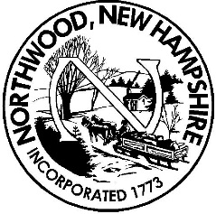 Board of Selectmen
Meeting Agenda
Northwood Town Hall
January 8st, 2019
6:00 p.m.

- Call to Order, Roll Call and Pledge of Allegiance

- Public Hearing – 6:00 p.m- 7:00 p.m.

- Citizen’s Forum (no more than 3 minutes per person at Board’s discretion)

- Appointments- 7:15 RA Jon Boudreau—Highway Dept.

- Non-Public Session 7:30 RSA 91-A:3, II (a – personnel)

- 2019 Warrant motions pending

- Unfinished Business

- Wage study

- New Business
  - Acceptance of Minutes
- December 21, 2018 meeting
  - Process Various Assessing Forms and Applications
- none
  - Approval of Manifest(s)
- Vendor Manifest
  - Approval of Purchase Orders
- Blanket purchase orders
  - Miscellaneous Signatures/Approvals

- Selectman deed
- Primex workers comp holiday distribution
- Primex unemployment holiday distribution
- Warm zone grants $6,000
- Homeland security / FEMA grant $10,338.09
Reports
  - TA’s work requiring directives from BOS
  - Individual Selectman’s Reports

- Citizen’s Forum (no more than 3 minutes per person at Board's discretion)

- Adjournment

Any person requiring interpretive or other accommodations is asked to contact the Town Office at least 48 hours prior to the start of the meeting.

