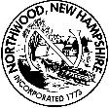
Northwood, NH Board of Selectmen
Meeting Agenda
Northwood Town Hall
June 17, 2019 –4:00 p.m.

4:00p.m. Open Culvert Bids

Adjournment
*Any person requiring interpretive or other accommodations is asked to contact the Town Office at least 48 hours prior to the start of the meeting.

