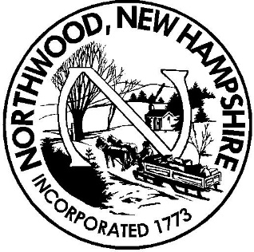

Town of Northwood

Budget Committee

AGENDA

4/11/2018

7:00 P.M.

Call Meeting to Order

Roll call

Minutes:

Election of Officers

Main Business:

Review of first quarter Town

Review third quarter School District

Internal Business:

Member Vacancy

Reminders/Upcoming Meetings

Recess/Adjournment

