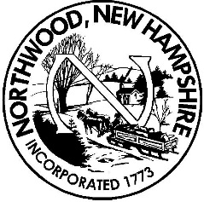 Board of Selectmen
Meeting Agenda
Northwood Town Hall
October 23, 2018
5:30 p.m.

- Call to Order, Roll Call and Pledge of Allegiance

- Non-Public Session RSA 91-A:3, II (a & c) – hiring of public employee & reputation of any person, other than a member of the board

6:00 PM Non-Public appt.

- Public Hearing – None scheduled

- Citizen’s Forum (no more than 3 minutes per person at Board’s discretion)

- Appointments –

8:00 PM Building Inspector Scott LaCroix wants to continue reviewing septic’s and fee change

- FY 2019 Budget Review

6:15 PM Parks & Recreation pg.20
6:30 Police Department; pg. 9-11

6:45 Police Commission; pg. 9

7:00 to 8:00 as BOS calls forward:
Animal Control; pg. 17-18
PD Wage Grant Program; pg. 23
Planning and Development; pg. 7
Zoning Board of Adjustments; pg. 7-8
Conservation; pg. 24
Budget Admin; pg. 6
Library; pg. 21- 23
Treasure: pg. 6
Trustee of Trust Fund; pg.6
Audit Services; pg. 4
Assessing Admin; pg. 4

- Unfinished Business Additional

- New Business
  - Acceptance of Minutes
  - Process Various Assessing Forms and Applications
  - Approval of Manifest(s)
  - Approval of Purchase Orders
  - Miscellaneous Signatures/Approvals

Reports
  - Town Administrator’s Report
  - Individual Selectman’s Reports

- Citizen’s Forum (no more than 3 minutes per person at Board's discretion)

- Adjournment

Any person requiring interpretive or other accommodations is asked to contact the Town Office at least 48 hours prior to the start of the meeting.

